Identifying the similar attempts on the same dataset or Similar Research Questions

*“A Spatial Median Filter for Noise Removal in Digital Images”*

In this paper, they tested digital images on six different noise removal filters in those two filters we can use on chest-x rays as well. Those are Mean and Median. As per their experimental results “The worst performing filter of the six tests was the Mean filter. For all noise compositions containing at least p = 0.10 noise, it produced the least accurate results. The unmodified VMF was only marginally better than the Mean Filter. The most stable of the filters was the Component Median Filter, which had the best accuracy across all eleven tested noise compositions. For noise compositions containing p<=0.15” [1].

“*Performance Analysis of Image Smoothing Methods for Low Level of Distortion”*

Indicated that the conservative smoothing technique is best method among different image smoothing techniques to reduce the blur in an image. Main reason behind the better performance of adaptive median filtering is due to its ability to distinguish between noisy pixel and noise free pixel. This method is superior to other filters like mean and median filters in terms of its higher capability to preserve the detailed information in an image [2].

“*Identification of Images of COVID‑19 from Chest X‑rays Using Deep Learning*”

In this paper, they worked on different deep learning techniques such as ResNet, DenseNet, VGG19, vision pro etc., they compare the each algorithms on the results they got for Covid and non-covid images [3].

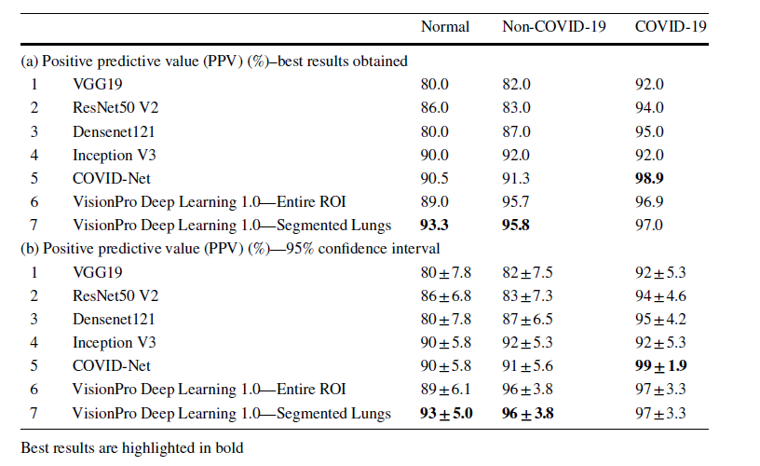

“*Paul M (2020) Kaggle chest X-ray images (pneumonia) dataset.*”

This is collection of Pneumonia images in which few members are working on the same dataset to deduct the pneumonia using different algorithms like resnet and denseNet etc., Few of them are still working on it [4].

*“TorchXRayVision: A Library of chest x-ray datasets and models”*

In this paper, they explained how they used the TorchXrayVision to deduct the ratio difference between two lungs using x-Rays.

TorchXRayVision is an open source software library for working with chest X-ray

datasets and deep learning models. It provides a common interface and common

pre-processing chain for a wide set of publicly available chest X-ray datasets

TorchXRayVision is an open source software library for working with chest X-raydatasets and deep learning models. It provides a common interface and commonpre-processing chain for a wide set of publicly available chest X-ray datasets [5].

TorchXRayVision:

A library of chest X-ray datasets and models

TorchXRayVision:

A library of chest X-ray datasets and models

TorchXRayVision:

A library of chest X-ray datasets and models

TorchXRayVision:

A library of chest X-ray datasets and models

TorchXRayVision:

A library of chest X-ray datasets and models

**“***False Negative Chest x-Rays in Patients Affected by COVID-19 Pneumonia and Corresponding Chest CT Findings***”**

Report four cases of false-negative chest x-rays, in patients who were diagnosed positive for COVID-19 by real-time transverse-transcript-polymerase chain reaction (RT-PCR), and executed chest unenhanced CT scans just after the X-Rays, demonstrating signs of COVID-19 pneumonia.

“*Customized VGG19 Architecture for Pneumonia Detection in Chest X-Rays*”

This paper develop a Deep-Learning System (DLS) to diagnose the lung abnormality using chest X-ray (radiograph) images.

(i) Conventional chest radiographs

(ii) Chest radiograph treated with a threshold filter. The initial experimental evaluation is carried out using the traditional DLS, such as AlexNet, VGG16, VGG19 and ResNet50 with a SoftMax classifier.

The results confirmed that, VGG19 provides better classification accuracy (97%) compared to other methods [7].

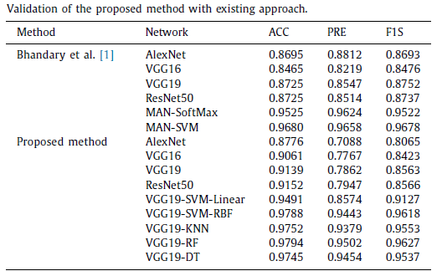

“*A New Approach for Classifying Coronavirus COVID-19 Based on Its Manifestation on Chest x-Rays Using Texture Features and Neural Networks.*”

In this paper authors tried to develop the system to auto detect the covid-19 positive cases such that they selected few different methods in each level and tested the dataset against the model.

Convolutional Neural Network with a classification accuracy of 83.02% and a superior AUC of 0.907, which would mean a better ability to detect the COVID19 using this method.

100% accuracy on the validation set using the feed-forward neural network, and this is using as inputs the flattened image and the texture features

Feature-based feed forward NN with an 84.02% classification accuracy and an AUC of 0.850 [8].

**References:**

*[1]. James C. Church, Yixin Chen, and Stephen V. Rice Department of Computer and Information Science, University of Mississippi, “A Spatial Median Filter for Noise Removal in Digital Images”, IEEE, page(s): 618- 623, 2008.*

*[2] Prabha, D. Surya, and J. Satheesh Kumar. “Performance Analysis of Image Smoothing Methods for Low Level of Distortion.” 2016 IEEE International Conference on Advances in Computer Applications (ICACA), 2016. https://doi.org/10.1109/icaca.2016.7887983.*

*[3] Arjun Sarkar, Joerg Vandenhirtz, Jozsef Nagy, David Bacsa, Mitchell Riley Identification of Images of COVID‑19 from Chest X‑rays Using Deep Learning IEEE trans*

*[4] Paul M (2020) Kaggle chest X-ray images (pneumonia) dataset.* [*https://www.kaggle.com/paultimothymooney/chest-xray-pneumonia/*](https://www.kaggle.com/paultimothymooney/chest-xray-pneumonia/)

*[5] Cohen, Sumner S. “Diseases of the Chest: With Emphasis on X-Ray Diagnosis.” Diseases of the Chest 13, no. 6 (1947): 734–36.* [*https://doi.org/10.1378/chest.13.6.734*](https://doi.org/10.1378/chest.13.6.734)*.*

*[6] Cellina, M., M. Orsi, T. Toluian, C. Valenti Pittino, and G. Oliva. “False Negative Chest x-Rays in Patients Affected by COVID-19 Pneumonia and Corresponding Chest CT Findings.” Radiography 26, no. 3 (2020).* [*https://doi.org/10.1016/j.radi.2020.04.017*](https://doi.org/10.1016/j.radi.2020.04.017)*.*

*[7] Nilanjan Dey , Yu-Dong Zhang , V. Rajinikanth, R. Pugalenthi , N. Sri Madhava Raja “Customized VGG19 Architecture for Pneumonia Detection in Chest X-Rays” IEEE Trans*

*[8] Varela-Santos, Sergio, and Patricia Melin. “A New Approach for Classifying Coronavirus COVID-19 Based on Its Manifestation on Chest x-Rays Using Texture Features and Neural Networks.” Information Sciences 545 (2021): 403–14. https://doi.org/10.1016/j.ins.2020.09.041.*